**Aim:** To configure DnS server to demonstrate the mapping of IP addresses and domain names.

**Topology:**

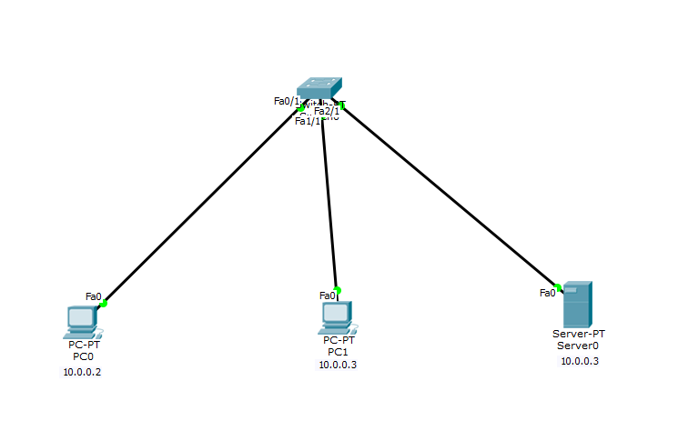

**Server configuration:**

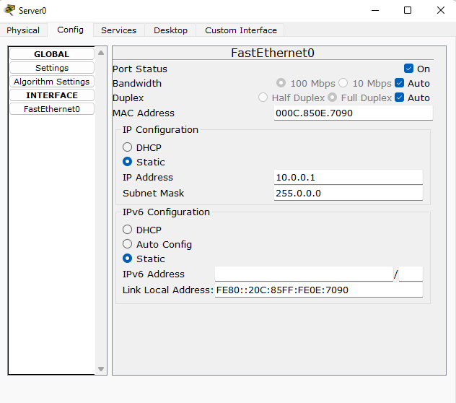

**DNS settings:**

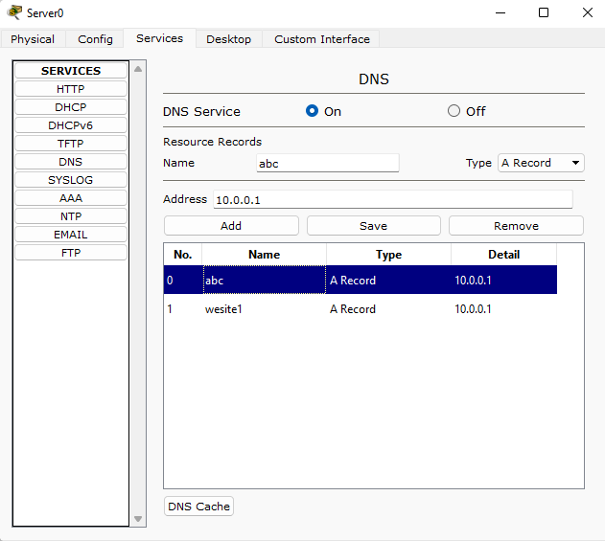

**Accessing website from PC1:**

